International Cybersecurity and Digital Forensics Academy (ICDFA)
CIP-B103: Network Forensics Fundamentals
LAB 1: HTTP Analysis Using Wireshark - Text Traffic
Three-Week Delivery Block 1/3 | 18-19 July 2026
Prepared by: Aminu Idris, AMCPN | Founder, ICDFA
Important Pre-Lab Instruction
Read the matching lecture slide deck before executing the practical. Work only inside the ICDFA-approved lab or your own isolated virtual environment. Record every command, observation and screenshot as contemporaneous evidence.
Course Code | CIP-B103
Course Title | Network Forensics Fundamentals
Student Name | Fuseini Imoru Kantuogaa
Student Reg. Number | 17291
Instructor Name | Dr. Sarah James
Lab Number | Lab 1
Lab Title | HTTP Analysis Using Wireshark - Text Traffic
Delivery Block | 1/3 of 3
Scheduled Dates | 18-19 July 2026
Estimated Duration | 3-4 hours practical work plus report writing
Mode | Individual practical lab in an authorized virtual environment
Required Evidence | basic.pcapng or basic.log generated locally; optional supplied basic.log

1. Source Materials and Slide Alignment
- HTTP, Wireshark and Digital Forensics Part 1: HTTP request/response, OSI encapsulation, TCP three-way handshake, sequence and acknowledgement numbers, connection termination and evidence reporting.
- The exercise reproduces a simple local Apache page, captures plaintext HTTP traffic, and inspects frame, IP, TCP and HTTP metadata.
- The slide assignment requires a named webpage, sender/receiver ports, initial sequence numbers, timestamps, IP addresses, MAC addresses and HTTP request timing.
Reading Requirement Before Lab Execution
The lab deliberately follows the sequence, terminology and core exercises presented in the uploaded CIP-B103 slides. Commands have been corrected where needed for Linux syntax and forensic repeatability.

2. Lab Scenario
You are a junior network forensic analyst asked to document a short plaintext HTTP session. You will create a local webpage containing your name and registration number, capture the traffic, reconstruct the TCP conversation, identify the HTTP request and response, and explain how each protocol layer contributes evidence.

3. Learning Outcomes
- Explain the forensic value of HTTP, TCP, IP and Ethernet metadata.
- Create and serve a simple HTML page using Apache.
- Capture HTTP traffic using Wireshark or tshark without altering the evidence.
- Identify the SYN, SYN-ACK and ACK packets in a TCP handshake.
- Extract source/destination ports, sequence numbers, acknowledgement numbers, timestamps and HTTP headers.
- Explain why loopback captures do not show normal Ethernet MAC addresses and repeat the capture on a two-VM network where required.
- Generate a concise network forensic timeline and evidence report.

4. Legal, Ethical and Safety Rules
- Use only systems, packet captures and networks for which you have explicit authorization.
- Keep the lab isolated from production, campus, office and public networks. Use NAT or host-only virtual networking as instructed.
- Do not collect, disclose or reuse real credentials, personal messages or confidential traffic.
- Preserve original capture files. Perform analysis on verified working copies and record SHA-256 hashes.
- Stop any traffic-generation or interception process immediately after the required evidence is captured.
- Restore firewall, ARP, forwarding and network settings before closing the lab.
- Do not browse to credential-bearing or private HTTP sites for this exercise. Use only the local page or the instructor-approved NeverSSL training page.

5. Required Tools and Environment
Item | Recommended Tool | Purpose
Operating system | Kali Linux or Ubuntu VM | Run Apache, curl, tshark and Wireshark.
Web server | Apache2 | Serve the training webpage locally.
Capture tools | Wireshark and tshark | Capture and inspect network packets.
Client | curl and a web browser | Generate controlled HTTP requests.
Hashing | sha256sum | Verify capture integrity.
Optional second host | Windows or Linux VM | Produce Ethernet frames with visible MAC addresses.

6. Lab Folder Structure and Evidence Preparation
mkdir -p ~/CIP-B103-Lab1/{evidence,working,exported,reports,screenshots,scripts}
cd ~/CIP-B103-Lab1
pwd
find . -maxdepth 1 -type d -print
Create the folder structure before downloading or generating evidence. Store original captures under evidence and analysis copies under working.
sudo apt update
sudo apt install -y apache2 curl wireshark tshark
sudo systemctl enable --now apache2
printf '<!DOCTYPE html>\n<html><body><h1>CIP-B103 HTTP Evidence</h1><p>Name: YOUR FULL NAME</p><p>Reg No: YOUR REGISTRATION NUMBER</p></body></html>\n' | sudo tee /var/www/html/basic.html
curl -v http://127.0.0.1/basic.html
# After capture:
sha256sum evidence/basic.pcapng | tee reports/basic_pcap_sha256.txt
Screenshot required: Apache status, the completed webpage in a browser, folder structure and the SHA-256 of the capture.
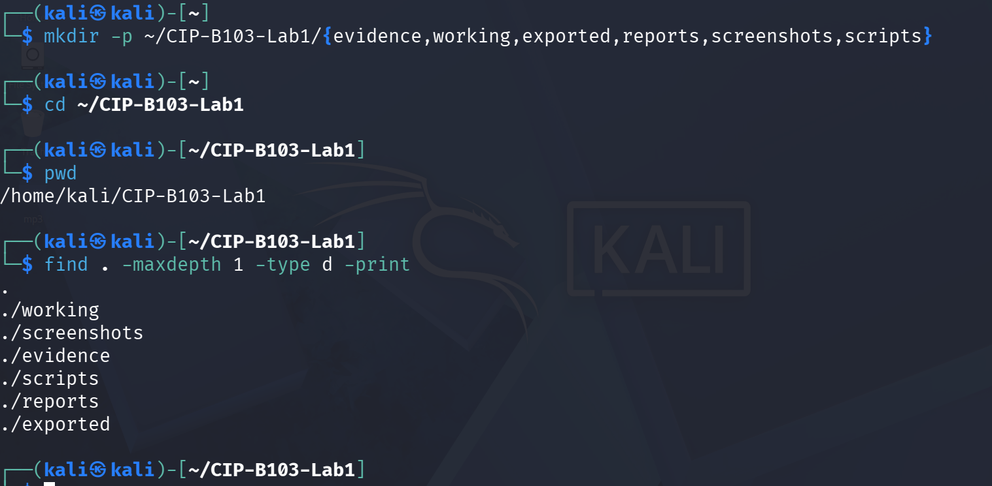
Screenshot 1: Evidence folder structure created (mkdir, cd, pwd, find).
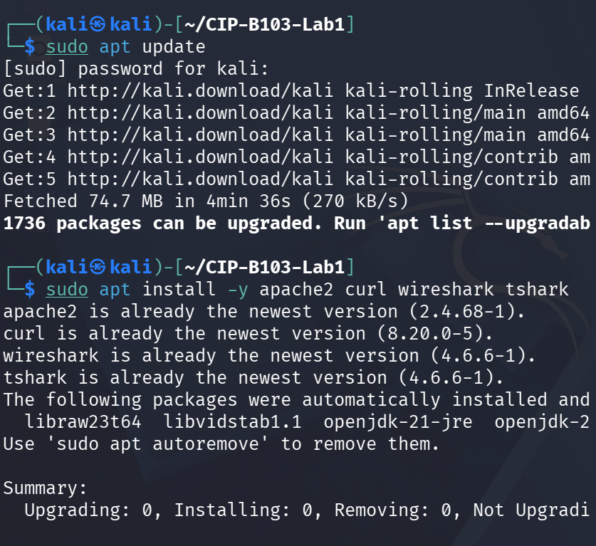
Screenshot 2: Package list updated and apache2, curl, wireshark, tshark installed.
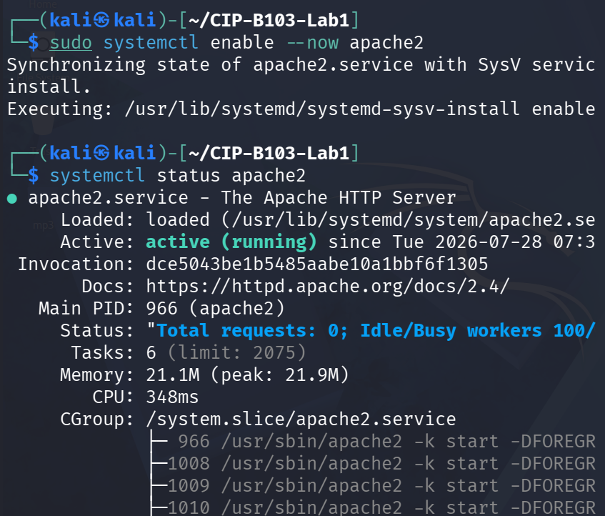
Screenshot 3: Apache2 enabled and systemctl status showing the service starting.
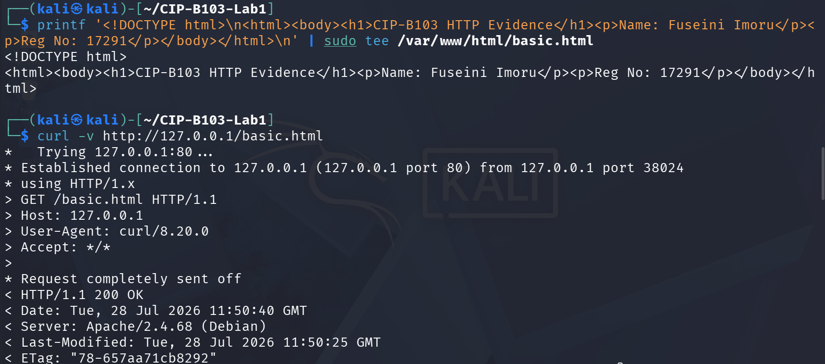
Screenshot 4: basic.html created with printf and the initial curl -v request/response headers.
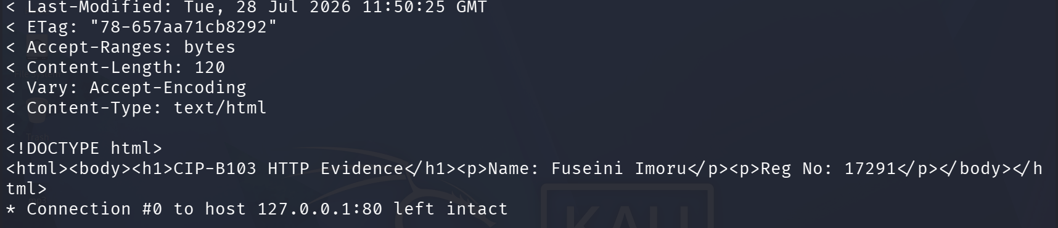
Screenshot 5: Continued curl -v output showing the HTML body and closed connection.

7. Mini Evidence and Chain-of-Custody Worksheet
Field | Student Entry
Case/lab identifier | CIP-B103-Lab1-YourFullName
Trainee name | Fuseini Imoru
Date and time started | Tue 28 July 2026, approx. 07:35 EDT (Kali VM) — inferred from the Apache2 service start time (07:35:31 EDT) shown in systemctl status
Evidence file name(s) | basic.pcapng (working copy: basic_working.pcapng)
Source or generation method | Captured locally with tshark on loopback (lo, tcp port 80) while curl requested http://127.0.0.1/basic.html served by the local Apache2 instance
Original SHA-256 | 53d0cadf491d24b130821c786a5d4a9478edd0a01986aeae0d1b36b2a647334f (preliminary Part A test capture, superseded) — final evidence/basic.pcapng used for analysis: 2e8b38d4cddf38b0e338f689287b45ebfc4ff939731da83e29fbfe5ea162617e
Working-copy SHA-256 | 2e8b38d4cddf38b0e338f689287b45ebfc4ff939731da83e29fbfe5ea162617e (working/basic_working.pcapng) — identical to the final evidence copy
Analysis workstation/VM | Kali Linux (user: kali), CIP-B103-Lab1 working directory
Notes on any changes | A first, informal capture/hash pair was made while verifying the webpage in Part A and was superseded by the official Part B capture. cp --preserve=timestamps was used for the working copy; SHA-256 of the final evidence and working copies matched exactly, confirming no alteration.

8. Part A - Verify the Web Service and Generate Text HTTP Traffic
- Replace the name and registration number placeholders in basic.html with your own details.
- Open http://127.0.0.1/basic.html and confirm that the page displays correctly.
- Run curl with verbose output and save the request/response headers.
- Record the local service state and listening port.
sudo systemctl status apache2 --no-pager
sudo ss -lntp | grep ':80'
curl -v http://127.0.0.1/basic.html 2>&1 | tee reports/curl_verbose.txt
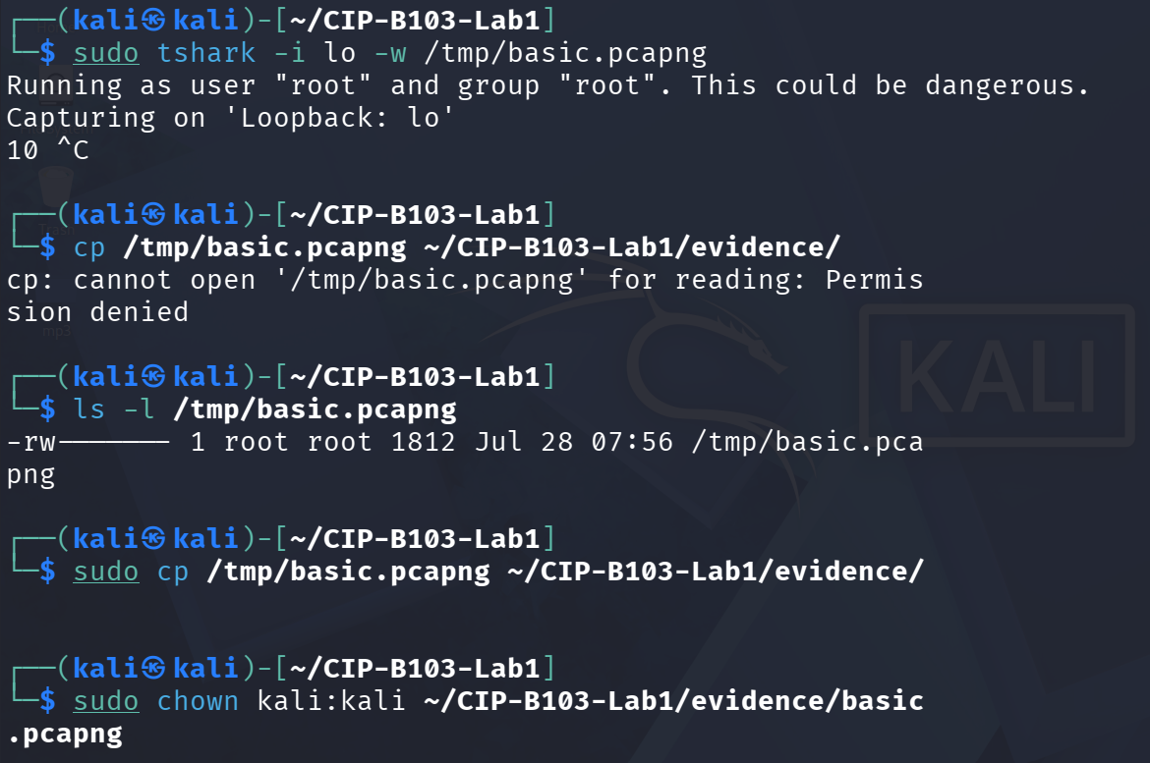
Screenshot 6: First loopback tshark capture attempt, corrected for a permission error and chown'd.
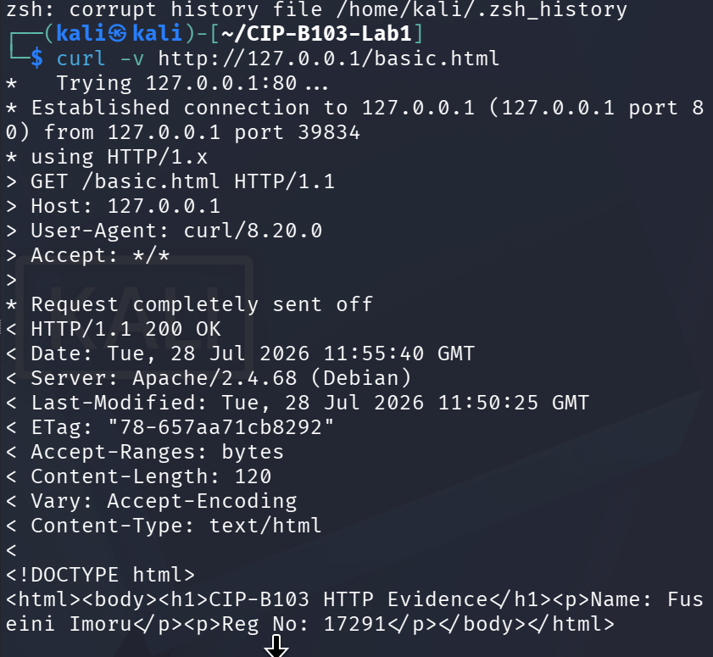
Screenshot 7: Repeat curl -v request to /basic.html generating a second HTTP exchange.
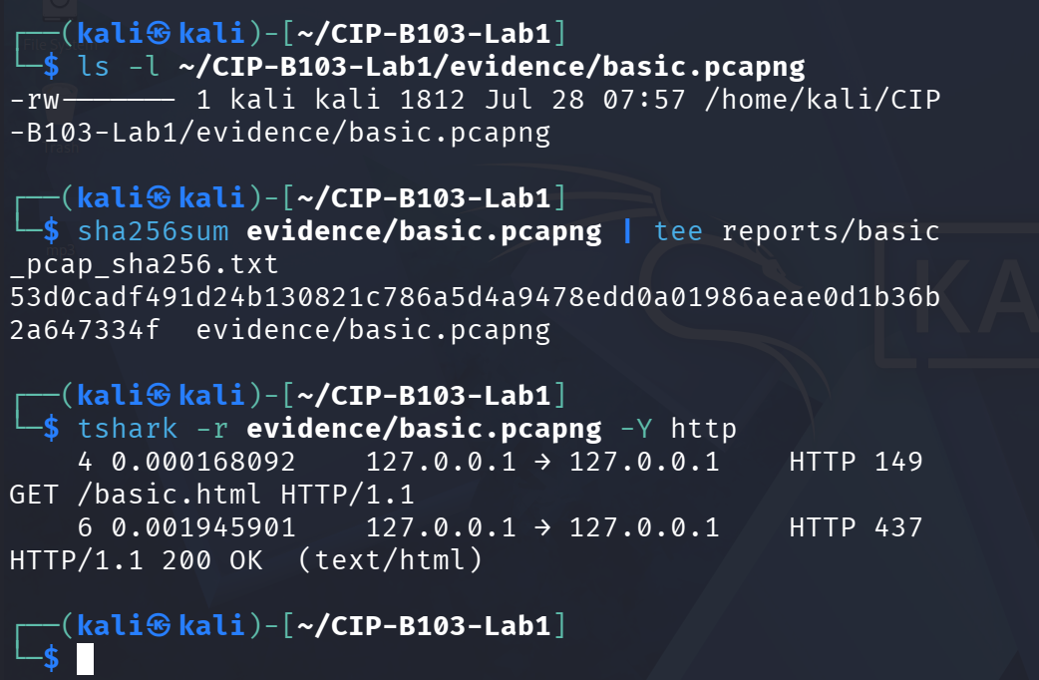
Screenshot 8: Evidence file listed, SHA-256 hashed, and inspected with tshark -Y http.
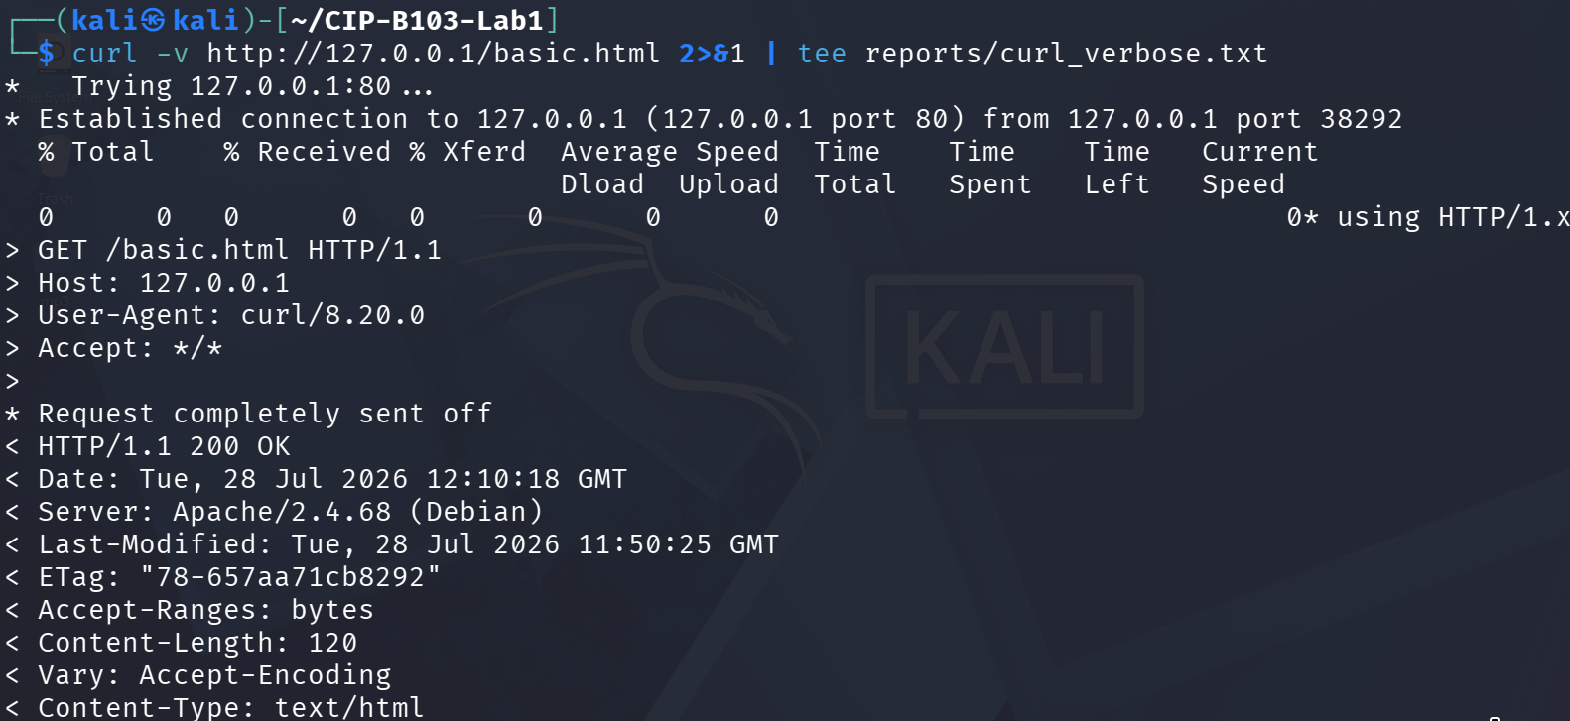
Screenshot 9: Part A curl -v request piped to reports/curl_verbose.txt.
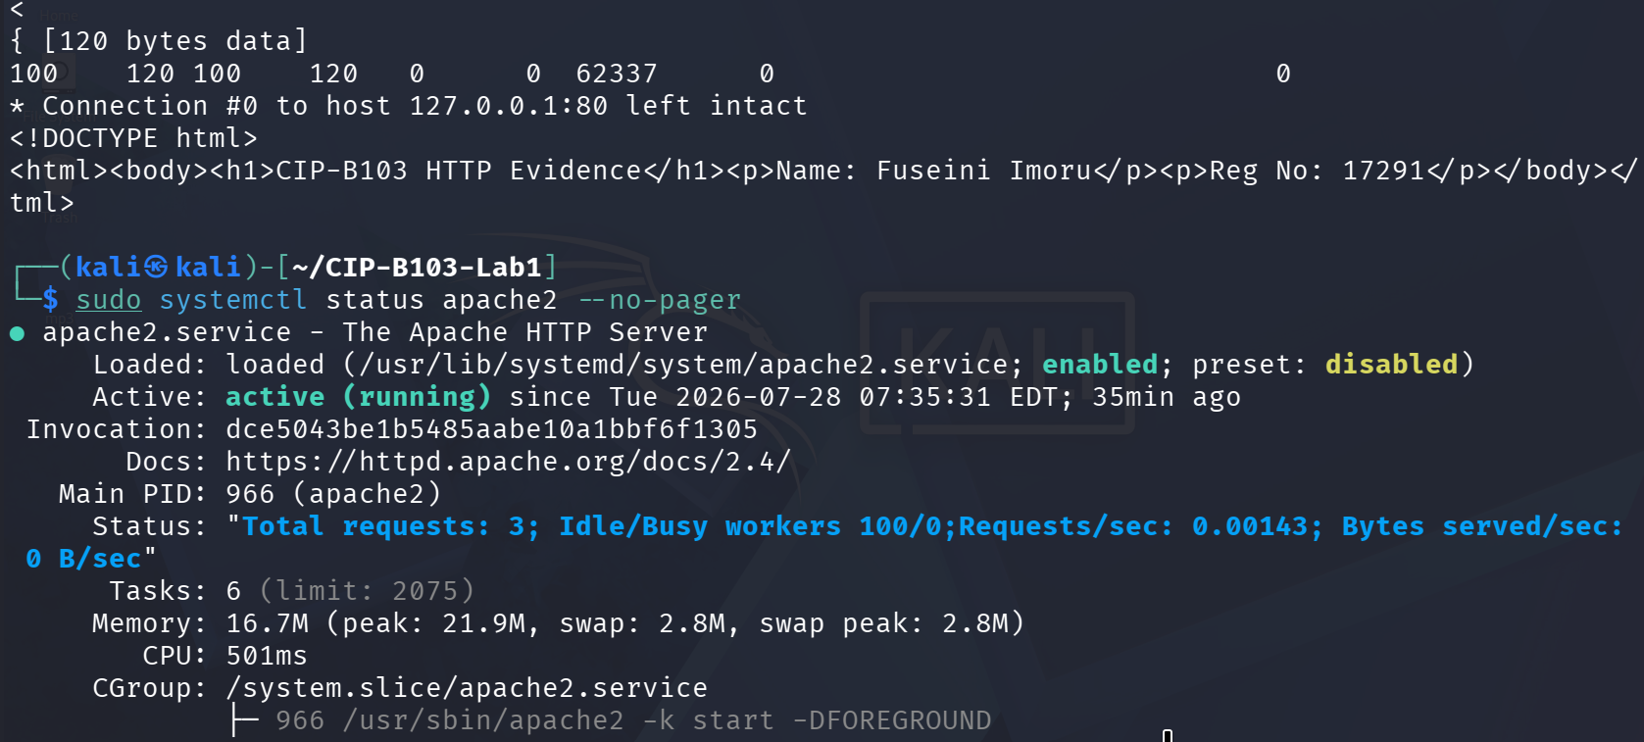
Screenshot 10: curl_verbose.txt continued and systemctl status apache2 --no-pager.
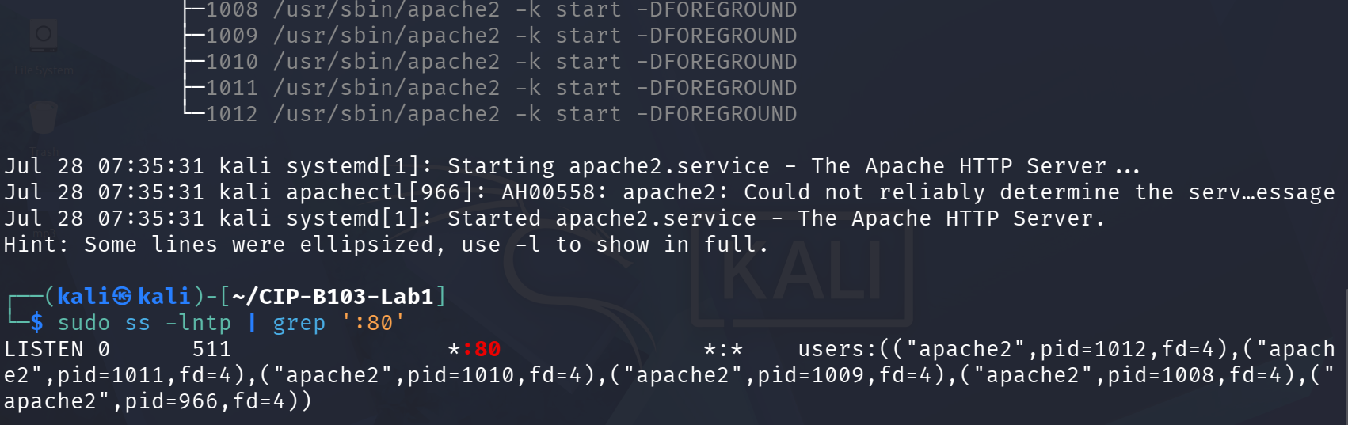
Screenshot 11: systemctl status continued and ss -lntp confirming Apache listening on TCP port 80.
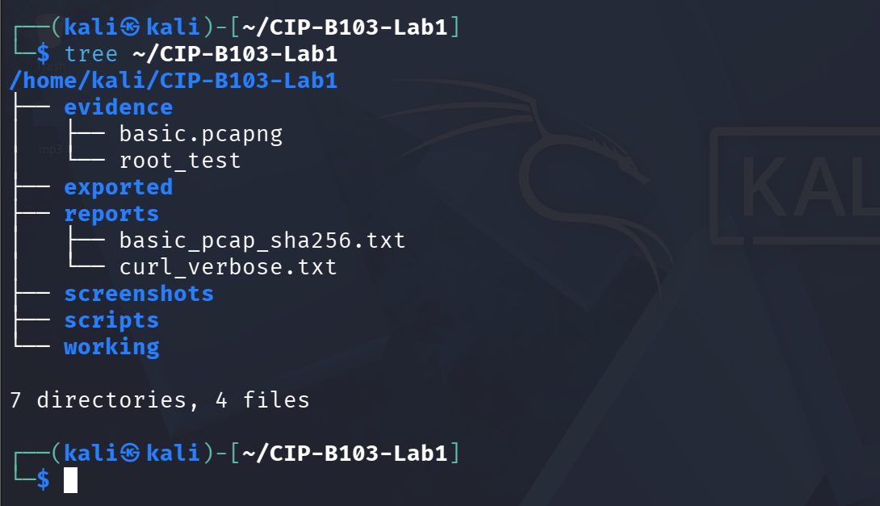
Screenshot 12: Evidence folder tree after Part A.

9. Part B - Capture the Session
Use either Wireshark or tshark. The loopback interface is normally lo. Start the capture before running curl and stop it after the page is received.
# Terminal 1
sudo tshark -i lo -f 'tcp port 80' -w evidence/basic.pcapng
# Terminal 2
curl --no-keepalive -v http://127.0.0.1/basic.html
# Stop Terminal 1 with Ctrl+C, then preserve a working copy
cp --preserve=timestamps evidence/basic.pcapng working/basic_working.pcapng
sha256sum evidence/basic.pcapng working/basic_working.pcapng | tee reports/capture_hashes.txt
Wireshark Alternative
Open Wireshark, select lo, apply capture filter tcp port 80, start capture, run curl, stop capture, and save as evidence/basic.pcapng.
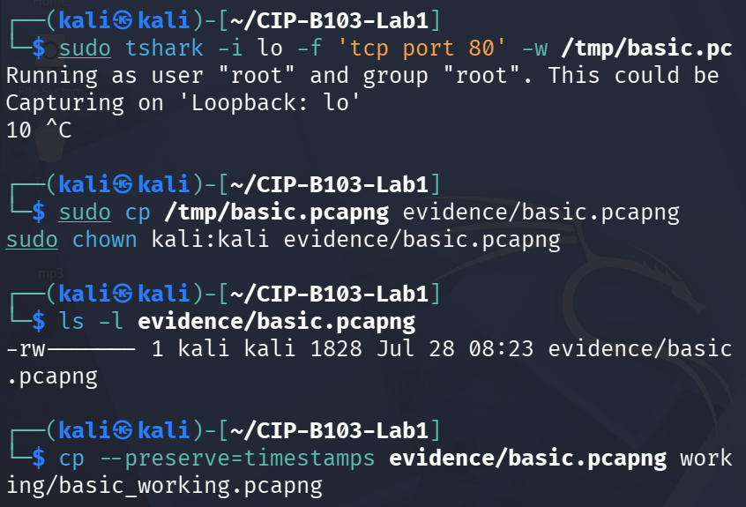
Screenshot 13: Official Part B loopback capture started, copied to evidence/, chown'd, and copied to a working copy.
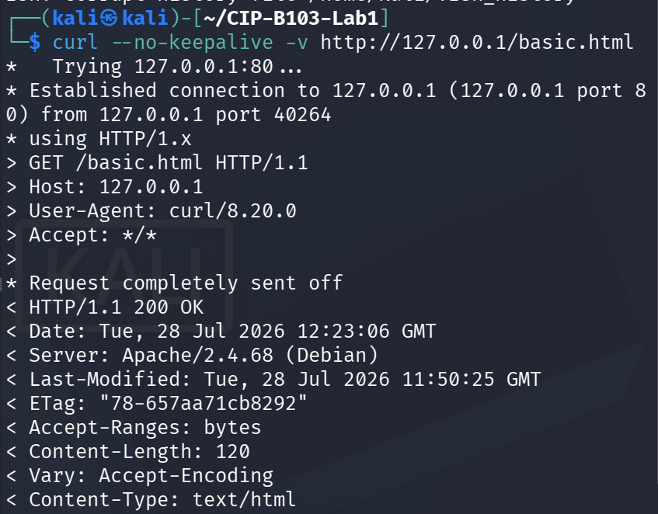
Screenshot 14: curl --no-keepalive -v request generating the analyzed HTTP session.
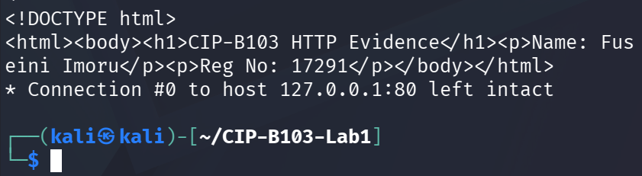
Screenshot 15: Continued curl output showing the HTML body and connection closure.
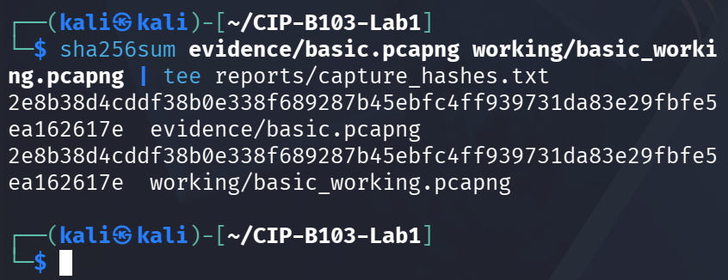
Screenshot 16: SHA-256 hashes of the evidence and working-copy captures (matching).

10. Part C - Analyze the TCP Three-Way Handshake
Open the working copy and apply the display filter tcp.stream eq 0. Identify the first three packets and complete the table.
Packet | Flags | Client Seq | Server Seq/ACK | Timestamp | Interpretation
1 | SYN | Seq = 0 (relative ISN) | — (not yet set) | 08:23:06.532515 EDT, 28 Jul 2026 (frame 1) | Client requests a TCP session.
2 | SYN, ACK | — | Seq = 0, Ack = 1 (relative) | 08:23:06.532578 EDT, 28 Jul 2026 (frame 2) | Server acknowledges and provides its initial sequence number.
3 | ACK | Seq = 1, Ack = 1 (relative) | — | 08:23:06.532590 EDT, 28 Jul 2026 (frame 3) | Client acknowledges; the connection becomes established.
tshark -r working/basic_working.pcapng -Y 'tcp.stream eq 0 && tcp.flags.syn==1' \
-T fields -e frame.number -e frame.time -e ip.src -e tcp.srcport -e ip.dst -e tcp.dstport \
-e tcp.flags -e tcp.seq -e tcp.ack | tee reports/handshake.tsv
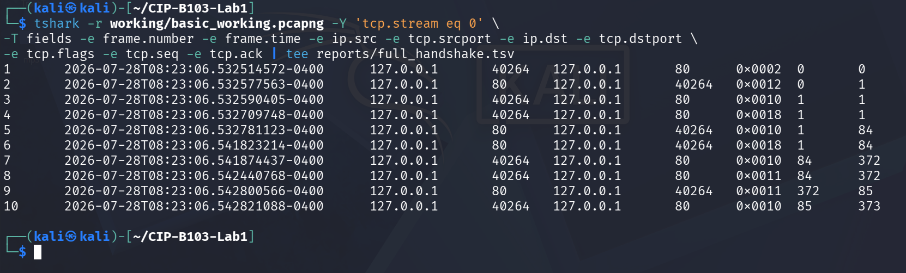
Screenshot 17: tcp.stream eq 0 field extraction showing the full 10-frame TCP conversation, including the three-way handshake.

11. Part D - Examine the HTTP Request and Response
- Filter for http.request and identify the GET method, request URI, Host and User-Agent.
- Filter for http.response and record the status code, response phrase, server and content type.
- Use Follow TCP Stream to reconstruct the complete request and response.
- Compare the TCP payload length with the sequence/acknowledgement progression.
tshark -r working/basic_working.pcapng -Y 'http.request' -T fields \
-e frame.number -e frame.time -e ip.src -e tcp.srcport -e ip.dst -e tcp.dstport \
-e http.request.method -e http.request.uri -e http.host -e http.user_agent \
| tee reports/http_requests.tsv
tshark -r working/basic_working.pcapng -Y 'http.response' -T fields \
-e frame.number -e frame.time -e http.response.code -e http.response.phrase \
-e http.server -e http.content_type -e http.content_length \
| tee reports/http_responses.tsv
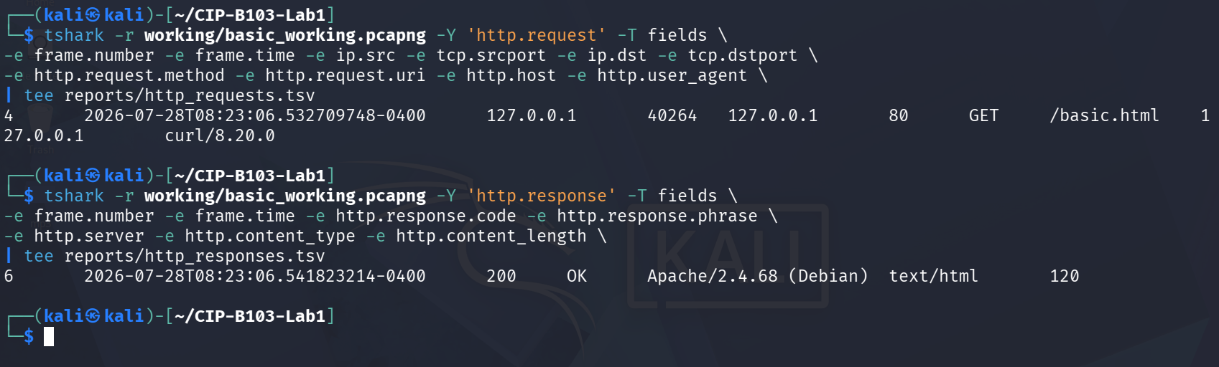
Screenshot 18: http.request and http.response field extraction showing the GET request and 200 OK response.

12. Part E - Inspect Encapsulation and Connection Closure
- Select the HTTP GET frame and expand Frame, Internet Protocol, Transmission Control Protocol and Hypertext Transfer Protocol.
- Explain the relationship among frame length, IP total length, TCP header length and TCP payload length.
- Locate FIN/ACK packets or a reset that closes the session. Explain the observed termination sequence.
- State why a loopback capture does not provide normal source/destination MAC addresses. For MAC evidence, repeat with two authorized VMs on the same host-only network.
tshark -r working/basic_working.pcapng -Y 'tcp.flags.fin==1 || tcp.flags.reset==1' \
-T fields -e frame.number -e frame.time -e ip.src -e tcp.srcport -e ip.dst -e tcp.dstport \
-e tcp.flags -e tcp.seq -e tcp.ack | tee reports/connection_close.tsv
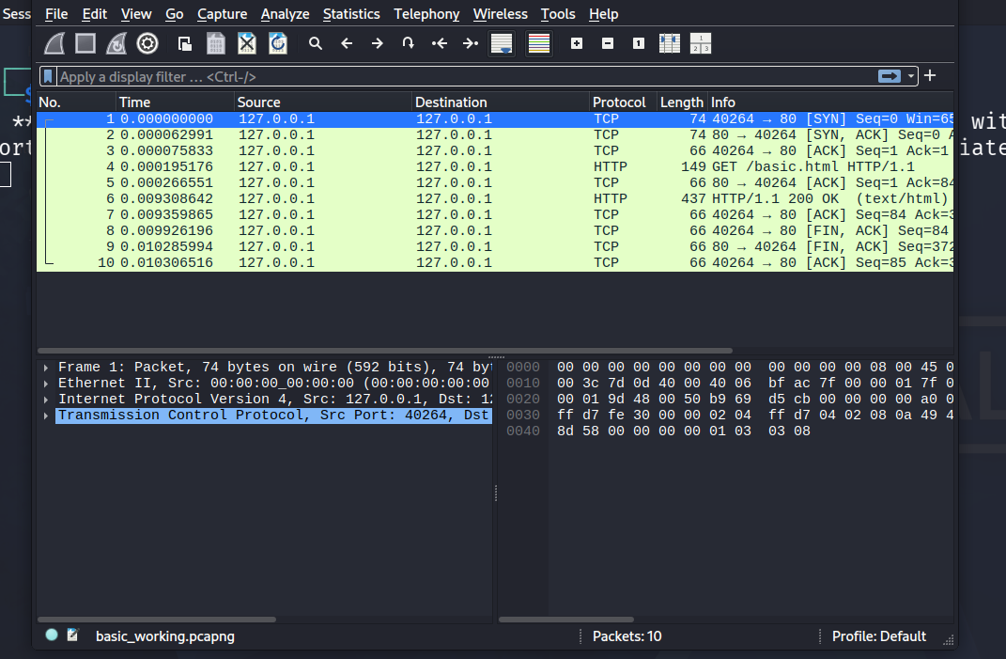
Screenshot 19: Wireshark packet list showing the handshake, HTTP GET/response and connection teardown.
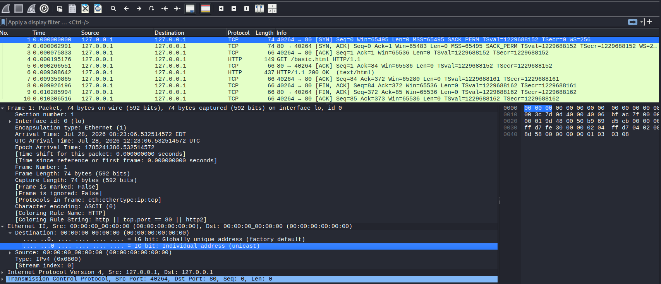
Screenshot 20: Expanded frame, Ethernet, IP and TCP layers for the GET request, showing loopback (all-zero) MAC addresses.
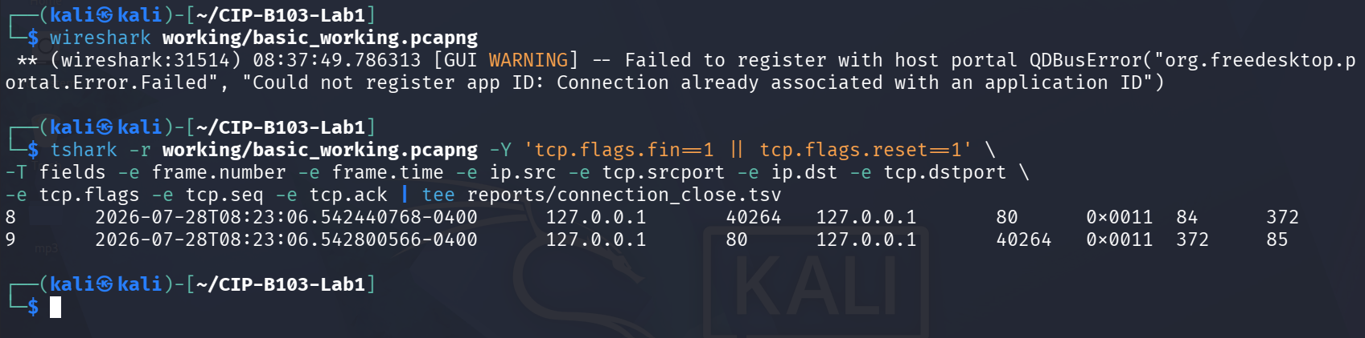
Screenshot 21: tshark filter for FIN/RST packets confirming the connection closure sequence.

13. Required Forensic Findings
Finding | Value/Observation
Capture start and end time | Started 08:23:06.532515 EDT (frame 1, SYN); ended 08:23:06.542821 EDT (frame 10, final ACK) — 28 Jul 2026, total span ~10.3 ms
Client IP and port | 127.0.0.1 : 40264
Server IP and port | 127.0.0.1 : 80
Client initial sequence number | 0 (relative)
Server initial sequence number | 0 (relative)
HTTP request timestamp | 08:23:06.532710 EDT, 28 Jul 2026 (frame 4)
Requested URI | /basic.html
HTTP response code | 200 OK (frame 6)
Content type and length | text/html, 120 bytes
Connection termination method | Graceful FIN/ACK exchange: client FIN,ACK (frame 8, Seq=84 Ack=372), server FIN,ACK (frame 9, Seq=372 Ack=85), completed by client's final ACK (frame 10, Seq=85 Ack=373)
MAC-address observation | Ethernet source and destination both show 00:00:00_00:00:00 (all-zero placeholder) on the loopback interface; genuine MAC addresses are absent because lo traffic never traverses a real NIC — a two-VM host-only capture would be needed to observe real MACs

Required Screenshots Checklist
☐ Webpage showing your name and registration number.
☐ Apache service listening on TCP port 80.
☐ Capture running on the selected interface.
☐ Three-way handshake with sequence and acknowledgement numbers.
☐ HTTP GET request and complete headers.
☐ HTTP 200 response and HTML content.
☐ Follow TCP Stream output.
☐ TCP connection closure.
☐ Capture hashes.
☐ Optional two-VM capture showing source and destination MAC addresses.

Student Report Template
- Cover page and executive summary.
- Authority, scope and evidence description.
- Environment and acquisition method.
- Chronological packet timeline.
- Handshake analysis.
- HTTP request/response reconstruction.
- Encapsulation and MAC-address explanation.
- Findings, limitations and conclusion.
- Appendix of commands, hashes and screenshots.

Submission Requirements
- One PDF report named CIP-B103-Lab1_RegNo_FullName.pdf.
- The original or generated PCAP/PCAPNG evidence file and its SHA-256 hash text file.
- A reports folder containing exported CSV/TXT command output and any recovered objects.
- Screenshots must be readable, numbered and referenced in the report narrative.
- Compress the report and evidence outputs into one ZIP named with your registration number and lab number.
- Do not submit passwords or decoded credentials in public discussion channels; include them only in the protected assessment submission where required.

Marking Rubric (100 Marks)
Assessment Area | Marks | What the Instructor Will Check
Preparation and evidence handling | 10 | Correct webpage, folders, capture preservation and hashes.
Traffic capture | 15 | Valid capture containing a complete HTTP session.
TCP handshake analysis | 20 | Correct flags, ports, timestamps, sequence and acknowledgement interpretation.
HTTP analysis | 25 | Correct request, response, headers, payload and stream reconstruction.
Encapsulation and closure | 15 | Correct layer and termination analysis, including loopback/MAC explanation.
Report quality | 15 | Clear timeline, screenshots, references and conclusions.

Instructor Quick Answer Guide
Checkpoint | Expected Observation
Default server port | TCP 80.
Handshake | SYN, SYN-ACK, ACK.
Request | GET /basic.html with Host and User-Agent headers.
Response | Usually HTTP/1.1 200 OK and text/html.
Loopback MACs | Normal Ethernet MAC addresses are not present on lo.
Sequence rule | ACK normally points to the next byte expected; SYN consumes one sequence number.

Command Reference Summary
Command | Purpose
curl -v URL | Generate an HTTP request and show headers.
tshark -i lo -w file.pcapng | Capture loopback traffic.
http.request | Wireshark display filter for HTTP requests.
tcp.stream eq 0 | Display one TCP conversation.
Follow TCP Stream | Reconstruct application data.
sha256sum file | Create an integrity hash.

Academic Integrity and Authorization Statement
Student Declaration
I confirm that I completed this lab in an authorized environment, preserved the supplied evidence, did not target any third-party system, and accurately documented my own commands, observations and conclusions.

